# Project: Analyzing a Market Test

## Step 1: Plan Your Analysis

1. What is the performance metric you’ll use to evaluate the results of your test?

Gross margin is the performance metric that I will use to evaluate the results of my test. We are interested in at least 18% increase in profit, and the gross margin is the only metric available for us to track it.

1. What is the test period?

We are running test for 12 weeks: 2016-April-29 to 2016-July-21.

1. At what level (day, week, month, etc.) should the data be aggregated?

The data should be aggregated at the week level.

## Step 2: Clean Up Your Data

*In this step, you should prepare the data for steps 3 and 4. You should aggregate the transaction data to the appropriate level and filter on the appropriate data ranges. You can assume that there is no missing, incomplete, duplicate, or dirty data. You’re ready to move on to the next step when you have weekly transaction data for all stores.*

## Step 3: Match Treatment and Control Units

*In this step, you should create the trend and seasonality variables, and use them along with you other control variable(s) to match two control units to each treatment unit. Note: Calculate the number of transactions per store per week to calculate trend and seasonality.*

*Apart from trend and seasonality...*

1. What control variables should be considered? Note: Only consider variables in the RoundRoastersStore file.

The two numeric variables that we should consider are: AvgMonthSales and Sq_Ft.

1. What is the correlation between each potential control variable and your performance metric?

Thanks to the Pearson Correlation Analysis, we see that AvgMonthSales has a high correlation of 0.99 with the performance metric, which is the Sum of Gross Margin. We can also observe that Square Feet has a weak correlation of -0.05

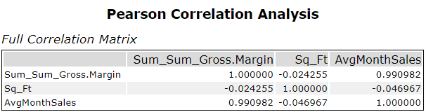

Figure 1. Pearson Correlation Analysis

1. What control variables will you use to match treatment and control stores?

I will use AvgMonthSales together with Seasonality and Trend when I will match treatment and control stores.

1. Please fill out the table below with your treatment and control stores pairs:

|  |  |  |
| --- | --- | --- |
| Treatments | Control 1 | Control 2 |
| 1664 | 7162 | 8112 |
| 1675 | 1580 | 1807 |
| 1696 | 1863 | 1964 |
| 1700 | 1630 | 2014 |
| 1712 | 7434 | 8162 |
| 2288 | 2568 | 9081 |
| 2293 | 9524 | 12219 |
| 2301 | 3102 | 9238 |
| 2322 | 2409 | 3235 |
| 2341 | 2383 | 12536 |

## Step 4: Analysis and Writeup

*Answer these questions. Be sure to include visualizations from your analysis:*

1. What is your recommendation - Should the company roll out the updated menu to all stores?

I would recommend rolling up with the updated menu to all stores. The AB analysis tools predict increase The average percentage change in Sum_Gross Margin was 39.5% for the treatment units in the test period relative to the comparison period.

1. What is the lift from the new menu for West and Central regions (include statistical significance)?

**West Region**

For the west region, we can observe a 37.9% improvement at 99.5% significance. The average lift we can see for each store is 37.9% or approximately 526.5$ per store per week.

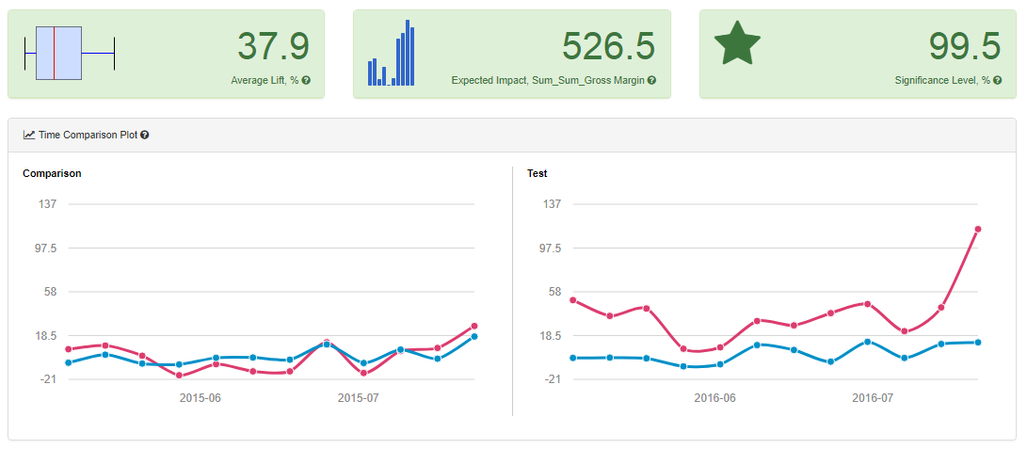

Figure 2. AB Test Analysis for Sum Gross Margin for West Region

**Central Region**

For the central region, we can see a 43.5% improvement at 99.6% significance. The average lift we can observe for each store is 43.5% or approximately 835.9$ per store per week.

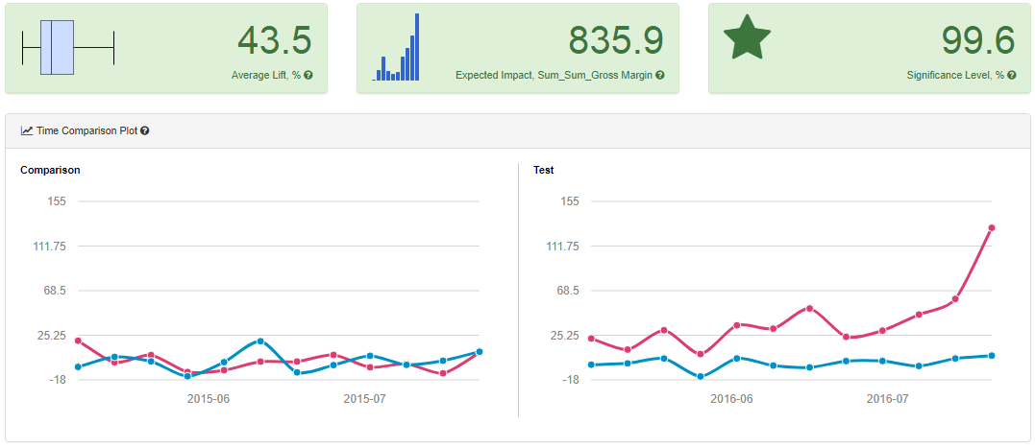

Figure 3. AB Test Analysis for Sum Gross Margin for Central Region

1. What is the lift from the new menu overall?

**Overal:**

For the new menu, we can see a 40.7% improvement at 99.6% significance. The average lift we can observe for each store is 40.7% or approximately 681.2$ per store per week.

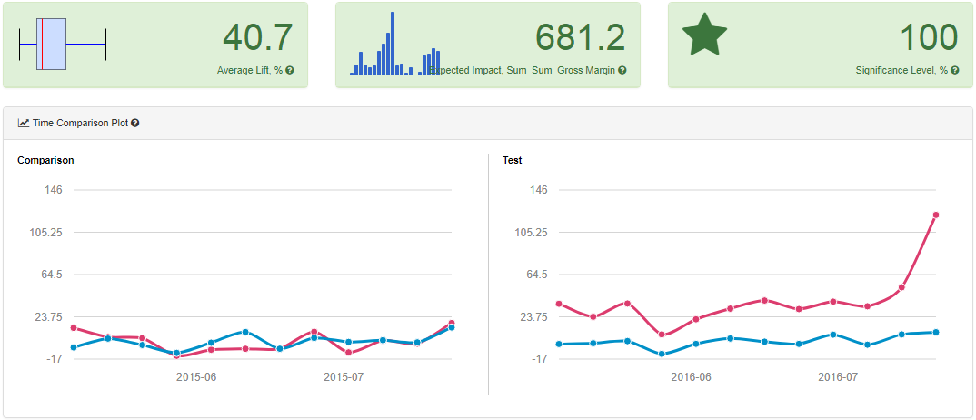

Figure 4. AB Test Analysis for Sum Gross Margin - Overal

# 

# Alteryx Workflows

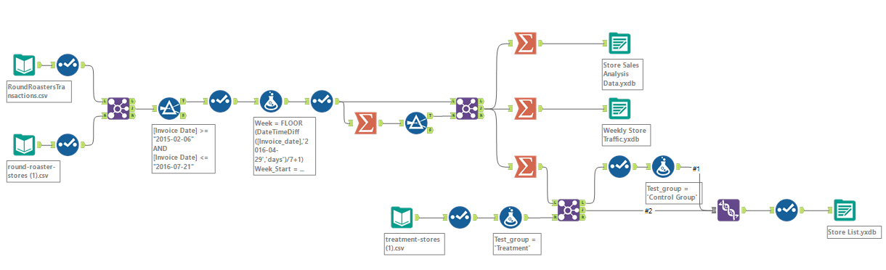

Workflow 1. Data Preparation

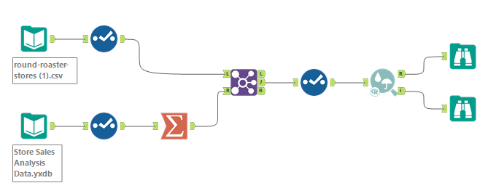

Workflow 2. Pearson Correlation Analysis

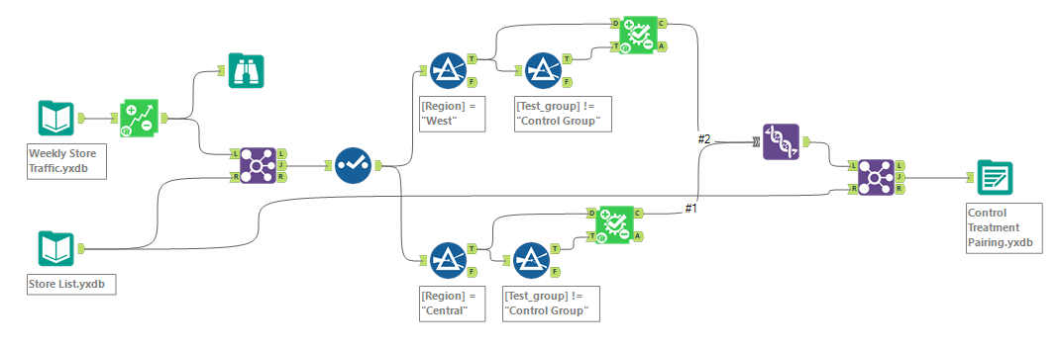

Workflow 3. Creating Control and Treatment Groups

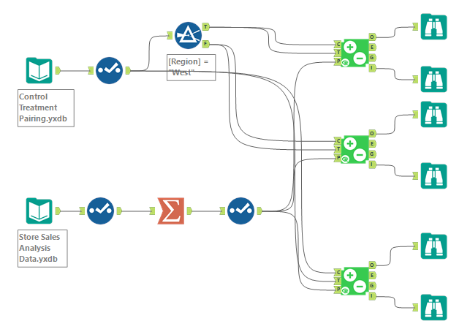

Workflow 4. AB Analysis